
Subject: Programming with Java
ASSIGNMENT No : 19
TITLE: Develop a Java application to establish connectivity with a database and perform data retrieval using the SELECT operation.

Name: Avdhoot Mohite Class: CSE A2
PRN: 25070122056 Batch:25-29

Problem Statement
Develop a Java application to establish connectivity with a database and perform data retrieval using the SELECT operation.
Learning Objectives
To establish database connectivity and retrieve records using JDBC SELECT statements.
Theory
Java Database Connectivity (JDBC) is a standard Java API that enables communication between Java applications and relational databases. It provides a platform-independent mechanism to connect to databases such as MySQL, Oracle, PostgreSQL, and SQL Server. Before executing SQL statements, a JDBC driver is loaded and a connection is established using the DriverManager class. The Connection object represents an active connection to the database, while the Statement object is used to execute SQL queries. The SELECT statement retrieves records from database tables based on specified conditions. The retrieved records are stored in a ResultSet object, which allows sequential access to the data. JDBC simplifies database programming and is widely used in desktop, web, and enterprise applications.
Outcome
The Java applications were successfully implemented to establish connectivity with a MySQL database using JDBC. Student records and product details were retrieved from database tables using SELECT queries and displayed on the console. The experiment provided practical understanding of JDBC connectivity, SQL SELECT statements, Statement objects, and ResultSet objects.
Conclusion
Thus, the experiment successfully demonstrated database connectivity and data retrieval using Java JDBC. The DriverManager and Connection classes were used to establish a connection with the database, while the Statement class was used to execute SELECT queries. The retrieved records were accessed using the ResultSet object and displayed successfully. This experiment provided a basic understanding of integrating Java applications with relational databases.

Exercise
1. Create a Java application to display student records from database using SELECT query.
import java.sql.*;

public class assignment19a {
public static void main(String[] args) {

String url = "jdbc:mysql://localhost:3306/college";
String username = "root";
String password = "Avdrocks@0504";

try {
// Load JDBC driver
Class.forName("com.mysql.cj.jdbc.Driver");

// Establish database connection
Connection con = DriverManager.getConnection(
url, username, password
);

// Create statement
Statement stmt = con.createStatement();

// Execute SELECT query
String query = "SELECT * FROM student";
ResultSet rs = stmt.executeQuery(query);

// Display student records
System.out.println("Student Records:");
System.out.println("---------------------------------------------");

while (rs.next()) {
System.out.println("Roll No: " + rs.getInt("rollno"));
System.out.println("Name: " + rs.getString("name"));
System.out.println("Marks: " + rs.getInt("marks"));
System.out.println("Grade: " + rs.getString("grade"));
System.out.println("City: " + rs.getString("city"));
System.out.println("---------------------------------------------");
}

// Close resources
rs.close();
stmt.close();
con.close();

} catch (Exception e) {
System.out.println("Error: " + e.getMessage());
}
}
}

OUTPUT:
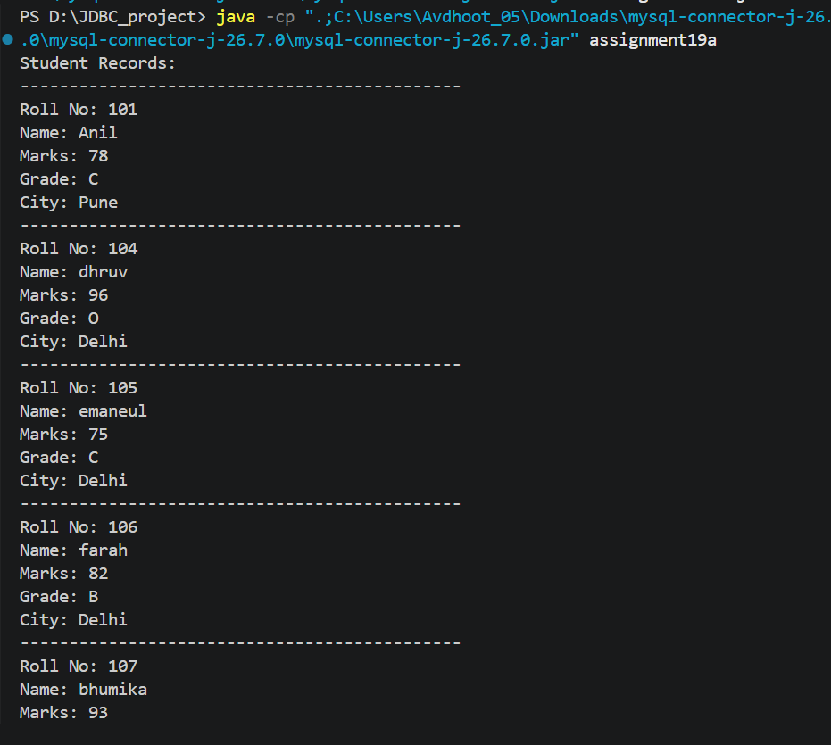

2. Create a Java application that connects to a database and displays product details using a SELECT query. Show product ID, product name, quantity, and price.
CODE:
import java.sql.*;

public class assignment19b {
public static void main(String[] args) {

String url = "jdbc:mysql://localhost:3306/practice";
String username = "root";
String password = "Avdrocks@0504";

try {
// Load JDBC driver
Class.forName("com.mysql.cj.jdbc.Driver");

// Establish database connection
Connection con = DriverManager.getConnection(
url, username, password
);

// Create statement
Statement stmt = con.createStatement();

// Execute SELECT query
String query = "SELECT * FROM products";
ResultSet rs = stmt.executeQuery(query);

// Display product details
System.out.println("Product Details:");
System.out.println("---------------------------------------------");

while (rs.next()) {
System.out.println("Product ID: " + rs.getInt("product_id"));
System.out.println("Product Name: " + rs.getString("product_name"));
System.out.println("Quantity: " + rs.getInt("quantity"));
System.out.println("Price: " + rs.getDouble("price"));
System.out.println("---------------------------------------------");
}

// Close resources
rs.close();
stmt.close();
con.close();

} catch (Exception e) {
System.out.println("Error: " + e.getMessage());
}
}
}

OUTPUT:
